**Output:**

1. **Menu**

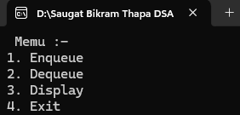

1. **Enqueue**

1. **Dequeue**

1. **Display**

